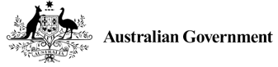

National Fuel Security Plan campaign

Stakeholder Kit
June 2026

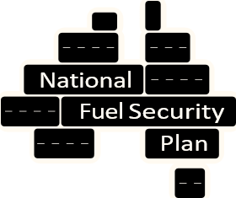

About the National Fuel Security Plan campaign
Like other nations, Australia is experiencing disruption to fuel supply due to global conflicts. The National Cabinet has agreed to the National Fuel Security Plan (the plan), which sets out a consistent response to fuel security across the Commonwealth, states and territories.
The plan has 4 levels – level 1 being the lowest and level 4 requiring the strongest actions to protect our fuel supply. We are currently at Level 2 of the plan – Keeping Australia moving.
The Every Little Bit Helps campaign informs Australians about the plan and raises awareness of some voluntary actions drivers can take in Level 2 to help reduce fuel consumption and ensure it remains available for the people, places and services that need it the most.
While the campaign encourages Australians to continue with their day-to-day activities, including holidays, attending events, going to work and visiting family and friends, it encourages drivers to consider alternative methods of travel or ways in which they can save fuel. The small measures we all take can make a difference.
This stakeholder kit provides content you can share with your networks to inform them about Australia’s approach to fuel supply and share some simple fuel-saving actions.
For more information about the Plan and simple fuel-savings tips, visit fuelplan.gov.au.
Thank you for your help sharing this important information.
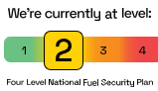

Newsletter/ Web copy
You can adapt this copy to use in your newsletter or website or share through your social channels.

Heading
Let’s work together to make our fuel supply go further

Body of article:
The National Fuel Security Plan (the Plan) is a framework to manage fuel supply in Australia. The Plan has been endorsed by National Cabinet and is based on 4 levels – with Level 1 being the lowest and Level 4 requiring the strongest action. We are currently at Level 2 - Keeping Australia moving.
As part of this, the Australian Government campaign Every Little Bit Helps raises awareness of the Plan and promotes voluntary actions that can help drivers reduce their fuel use for those able to do so, particularly in metropolitan areas.
Simple steps you can take include:
- Drive efficiently - avoid harsh acceleration and braking, use cruise control where possible, and avoid idling when parked or waiting.
- Remove excess weight - take unnecessary objects out of your car for better fuel efficiency
- Keep your tyres inflated to the recommended pressure
- When refuelling your car, stop at the first click of the pump
- Remove roof racks or external equipment from your vehicle when not in use
- Consider carpooling or ridesharing
- Use public transport where it is available
- If safe and practical, consider walking or cycling for short trips
By using less fuel, we can all help our supply go further and ensure it remains available for the people, places and services who need it most.
For more fuel saving tips or information about the plan, visit fuelplan.gov.au
Download graphics
View translated resources

Printable resources
These can be downloaded and printed as factsheets or posters.
Download graphics
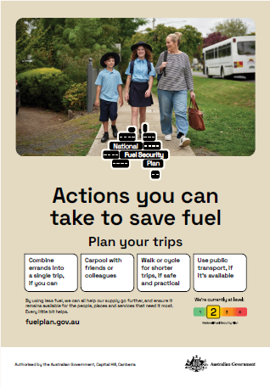

Social media posts
Here is some suggested social media copy and image tiles you can use on your social media channels and share with your networks.
You can adapt or tailor these messages to your audience and channels. Alternatively, you can share from the Australian Government LinkedIn, Facebook and Instagram accounts.

Suggested text
The Australian Government has a website and campaign to help keep you informed about what it’s doing to secure fuel.
The website has information on the National Fuel Security Plan, tips for drivers, and information on actions to date.
For more information visit: fuelplan.gov.au
#NationalFuelSecurity #FuelSecurityCampaign #FuelPlan
Download graphics

Thank you
Thank you for your help to share this important information. If you have any questions, contact:
Email: campaigns@communications.gov.au
You can also follow the Australian Government on LinkedIn, Facebook and Instagram.

